Product Intern Assignment

TANMAY SHRESTH | [tanmaybeginningup@gmail.com](mailto:tanmaybeginningup@gmail.com) | 8306695504

# Introduction

This report presents the findings of a data analytics project aimed at uncovering insights from a time series dataset. This project aims to showcase research skills in identifying, analyzing, and documenting patterns and trends within the dataset. The dataset used for this analysis is the Superstore sales data.

# Data Source

The dataset used in this analysis can be accessed from the Tableau Community [[LINK]](https://community.tableau.com/s/question/0D54T00000CWeX8SAL/sample-superstore-sales-excelxls). It consists of sales data for office supplies, furniture, and technology products.

# Data Description

* The dataset contains information on various aspects of sales, including order details, customer information, and product categories.
* It comprises over 10,000 entries and more than 10 columns.
* The key variables include Order Date, Ship Date, Ship Mode, Customer ID, Customer Name, Product Category, Sales, Quantity, Discount, and Profit.

# Data Cleaning and Preprocessing

To prepare the data for analysis, the following steps were taken:

* Unnecessary columns were removed.
* Missing values were checked and handled.
* Data was aggregated by date to facilitate time series analysis.

# 

# Data Exploration

## Sales Analysis for Technology

We initiated our analysis by focusing on the Technology category's sales trends. Below is a summary of our findings:

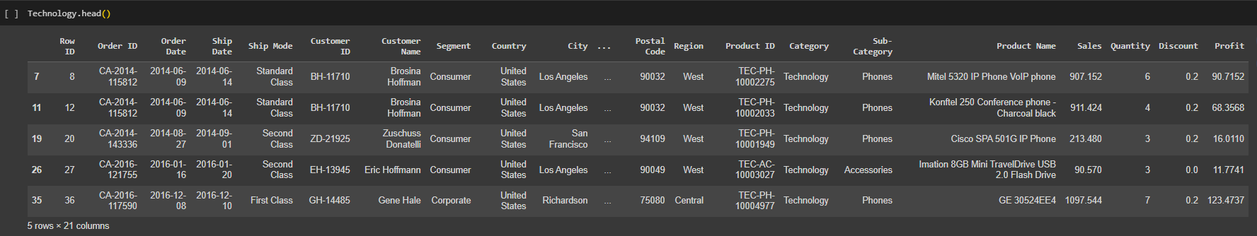

## Seasonality Analysis

We explored seasonality patterns in the sales data over different years and months. Here are the key insights:

### Sales Data 2014

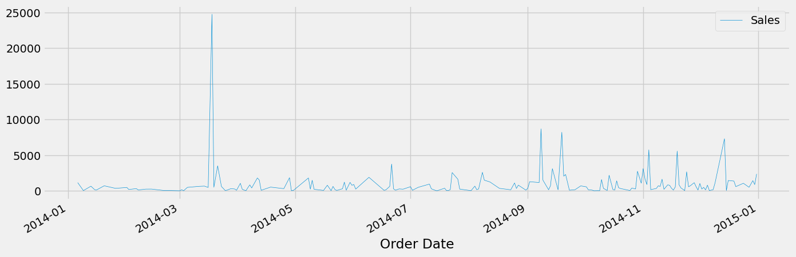

### Sales Data 2015

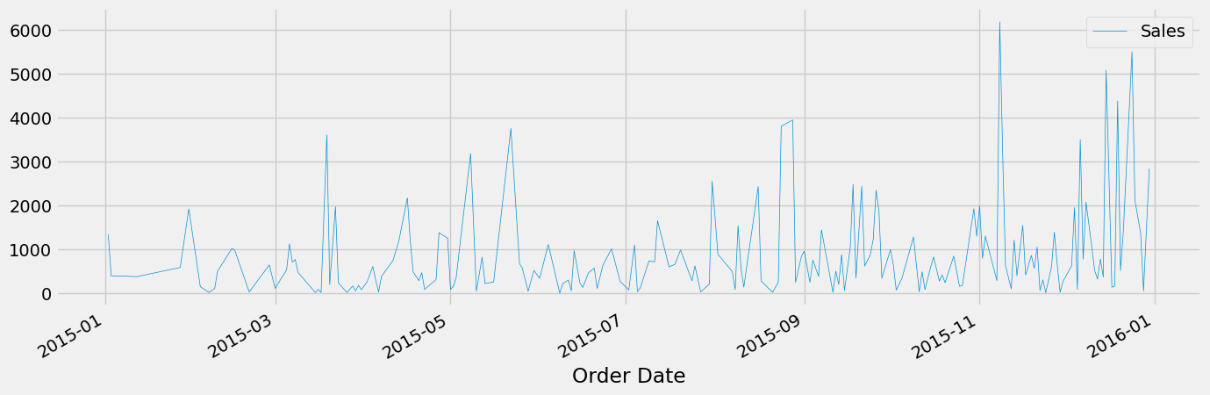

### Sales Data 2016

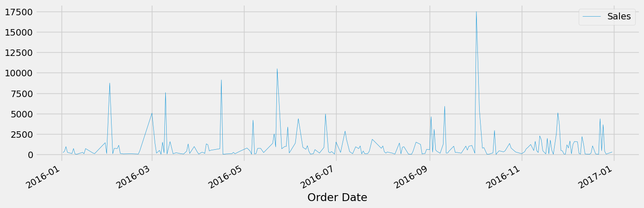

### Sales Data 2017

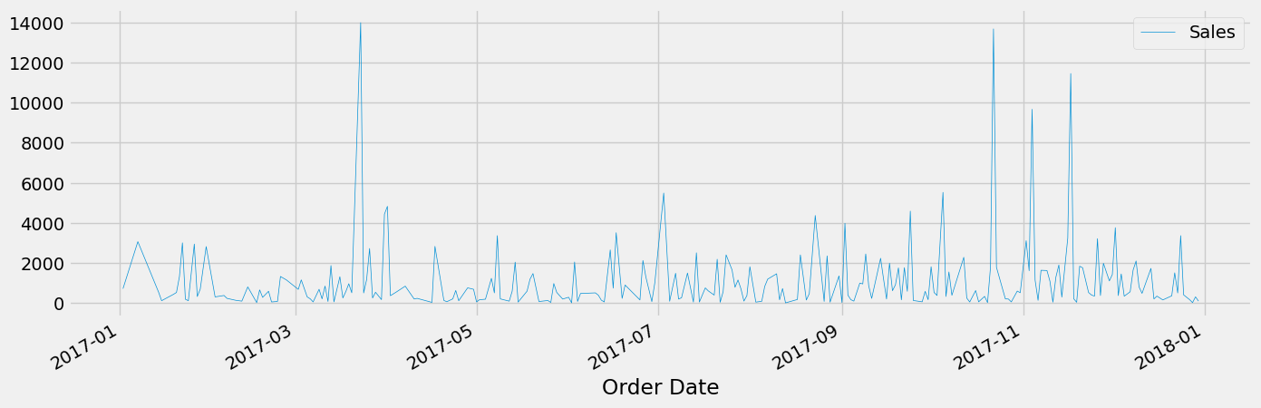

#### 

#### 

### Monthly Sales Data 2014-2017 (Quick Overview)

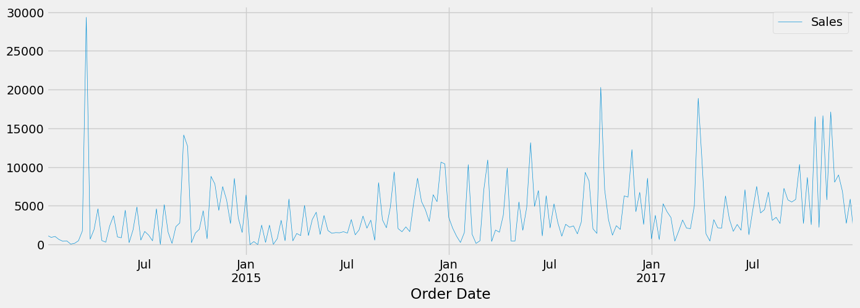

### Trend Analysis

We used regression analysis to identify sales trends over the years. Our observations are as follows:

#### 2014

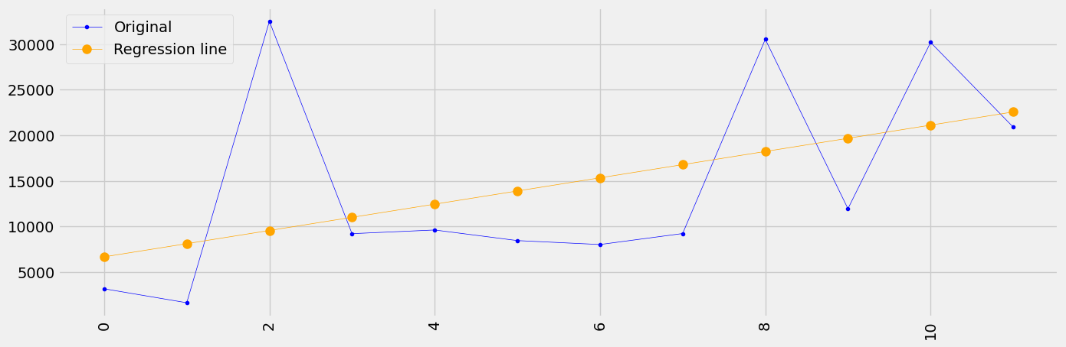

#### 2015

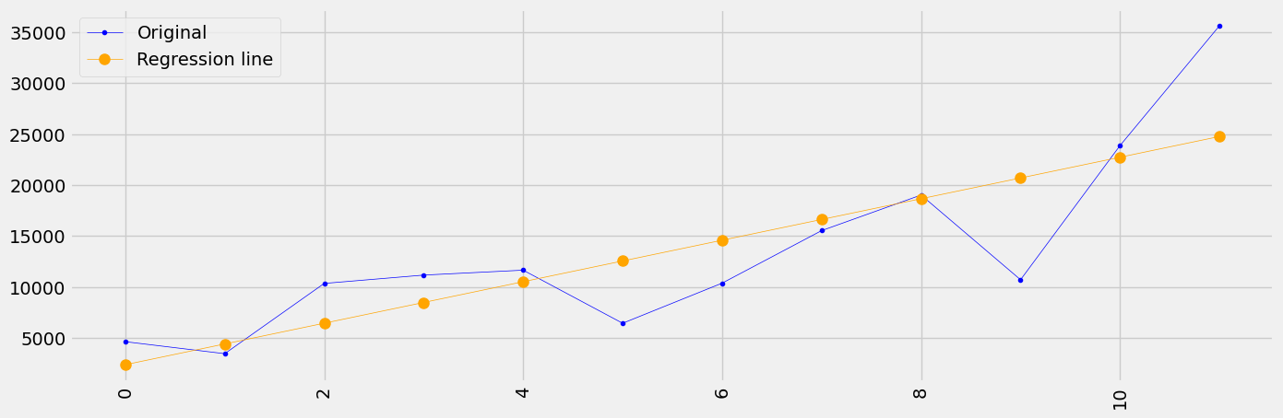

#### 2016

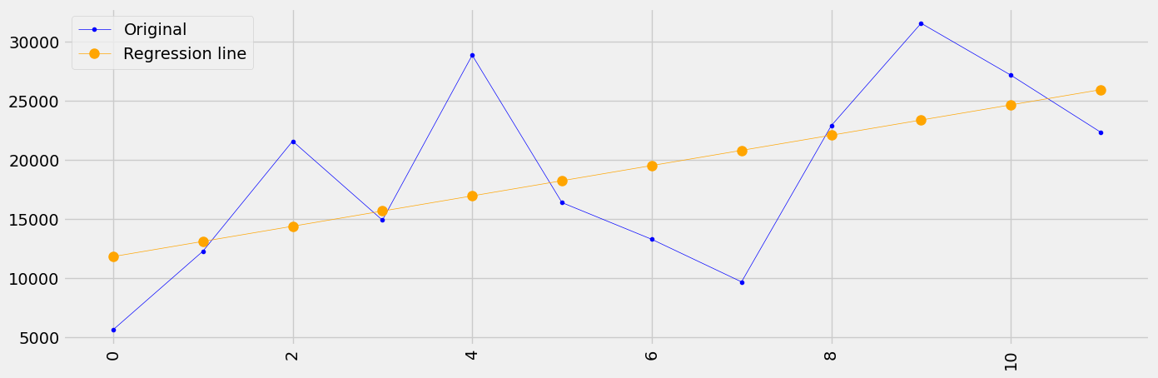

#### 2017

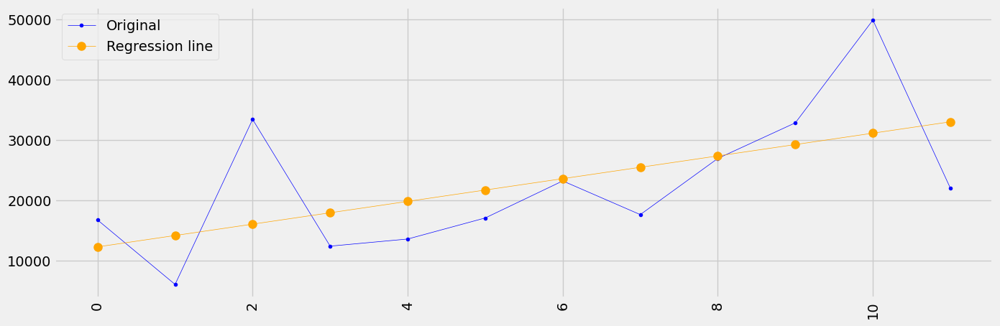

#### 2014-2018 (Consolidated Trend)

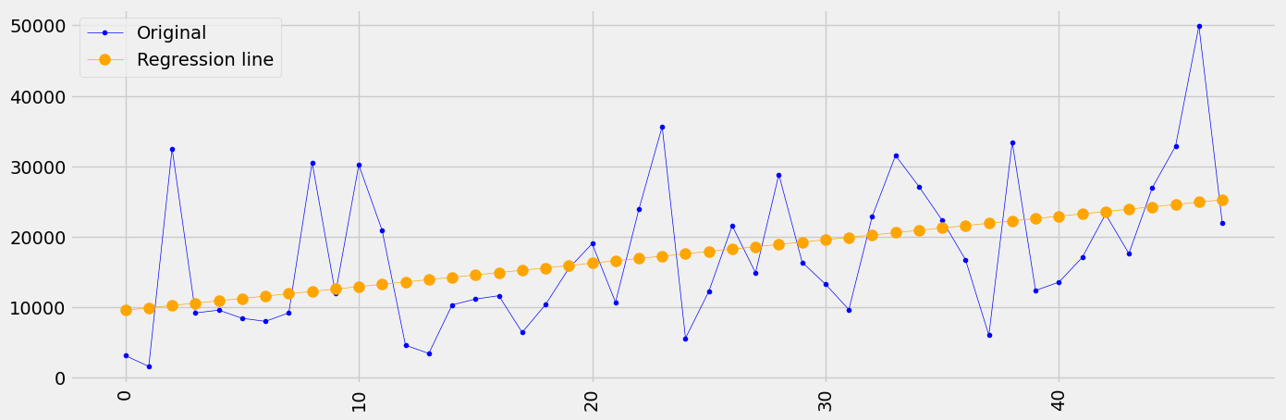

### Key observations:

* + The trend is more visible in the monthly sales data.
  + Consolidated 4 years show an uptrend in sales numbers.
  + Sales increase in the last quarter of every calendar year, indicating slight seasonality.
  + The time series exhibits a slight seasonal pattern, with low sales at the beginning and high sales at the end of the year.

# Code Attribution

For this analysis, I sought assistance from ChatGPT for ideas and used online resources like Stack Overflow, tableau for Data and Google for coding help and my friend.

[LINK](https://drive.google.com/file/d/1iz2MBrx5YYXr9-HId0-O1ahojmSCYLmR/view?usp=sharing)

# Conclusion

The analysis of the Superstore sales data for the Technology category has yielded valuable insights into sales trends and seasonality patterns. Here are the key conclusions:

* **Seasonality Patterns:** Examining sales data across different years and months revealed distinct seasonality patterns. Specifically, we observed that sales tend to be lower at the beginning of the year and progressively increase, reaching their peak towards the end of each calendar year. This seasonal variation implies that there are specific times of the year when demand for technology products is higher.
* **Upward Trend:** A regression analysis demonstrated a consistent upward trend in technology product sales over the four years from 2014 to 2017. This suggests that the demand for technology items has steadily grown.
* **Yearly Sales Uptrend:** A closer look at annual sales data reaffirms the presence of an upward trend. The consistent increase in sales each year is a promising sign for the Technology category.

# Recommendations

Building on the insights gained from the analysis, here are some actionable recommendations:

* **Inventory Management:** Given the observed seasonality patterns, it is advisable to adjust inventory levels accordingly. Prioritize stocking up on technology products towards the end of the year to meet the surge in demand during the holiday season.
* **Marketing Strategy:** Align marketing efforts with the seasonality trends. Plan marketing campaigns targeting peak sales periods, especially during the year's final quarter. Consider special promotions or discounts to capitalize on increased demand.
* **Product Expansion:** Evaluate the possibility of expanding the range of technology products offered. This can involve introducing new and trending items to cater to the growing demand in this category.
* **Customer Segmentation:** Segment customers based on their purchase behavior. Identify and target high-value customers who consistently purchase technology products and tailor marketing strategies to retain and nurture this segment.
* **Supply Chain Optimization**: Optimize supply chain processes to ensure timely deliveries during peak seasons. Efficient logistics can help in meeting customer demands promptly and enhancing customer satisfaction.
* **Data Continuation**: Collect sales data and perform regular analyses to monitor trends. This will enable proactive decision-making and adapting strategies based on evolving market dynamics.
* **Competitive Analysis**: Keep an eye on competitors within the technology product market. Understanding their strategies and pricing can inform your own pricing and marketing decisions.
* **Customer Feedback:** Actively seek and incorporate customer feedback. Customer preferences and suggestions can be invaluable in fine-tuning product offerings and improving overall customer satisfaction.